ADF ToolTip
Designed and Developed By: Anirudh Bajaj (IMC Global Technology Services Pvt. Ltd.)
The tooltip or infotip or a hint is a common graphical user interface element. It is used in conjunction with a cursor, usually a pointer. The user hovers the pointer over an item, without clicking it, and a tooltip may appear—a small "hover box" with information about the item being hovered over. Tooltips do not usually appear on mobile operating systems, because there is no cursor (though tooltips may be displayed when using a mouse). Tooltip are a quick way to provide extended information on a term or action on page.
At times it is required to have a small infotip or a tooltip to be appeared separately, not along with the ADF Components. So in such case this component is very handy. You can define attributes “message” which will display the text when mouse is been hovered and an “icon” attributes to define the path of the icon which you wanted to display of your own choice. To change the background of the window on which message is getting displayed or font of the message, you can override “abt-message” styleclass in your CSS.
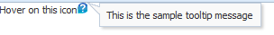
This project contains the jar file present in the deploy folder and code of implementation and does not use any third party jar file or any JQuery code.
Steps to use ADF ToolTip :
- The following step is to define File System connection in the resource palette to the deployment path of ToolTipComponentLib in the project:
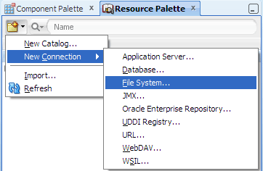

Provide the connection name and the path of the Jar File:

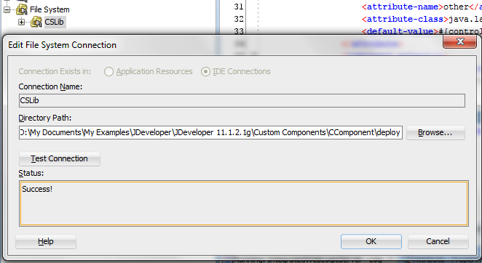

- Choose the project where the component is to be used (in my case Tooltip) and then Go to resource palette and add ToolTipComponentLib.jar library to it as shown in figure below:
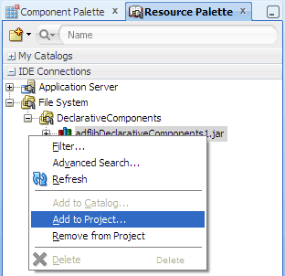

- After Clicking add to project, the Library file will be added to the selected project.
- Create a .jspx page inside the project and go to the Component palette. From the drop down, you can see there TooltipComponentLib. Select this and you are ready to drag and drop it on the page.
- Something below will be present when you drag and drop this component on to the page

<tool:ToolTipComp messge="Hello Text Message" id="ttc1" icon=”/icon/help.png”/>

